SIMATS ENGINEERING
ASSESSMENT TOOL 2

COURSE NAME: CSA07 COURSE CODE: Computer Networks

COURSE OUTCOME COVERED

CO1: Apply the functions of OSI layer in enabling reliable data transmission across networks. (BL2, BL3)

Assessment Tool Weightage: 30%

Annexure A

CONCEPT MAPPING

1. A partially completed concept map is given below:

Application → Presentation → ______ → Transport → Network → ______ → Physical.
Analyze the missing layers and explain how their functions are essential for reliable communication.

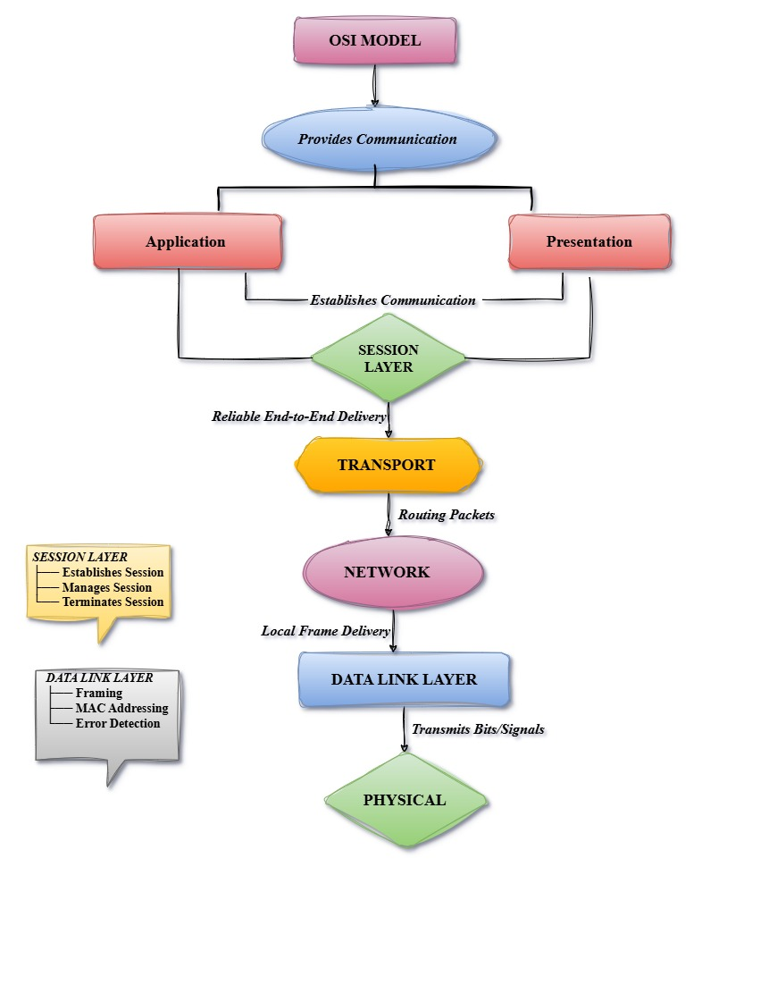

RUBRICS FOR CALCULATION

Criteria | Weightage (%) | Level 4 (Exemplary) | Level 3 (Proficient) | Level 2 (Developing) | Level 1 (Beginning)
Concept Identification | 20% | Accurately identifies all relevant OSI layers, concepts, and relationships | Identifies most concepts with minor omissions | Identifies limited concepts; some inaccuracies | Unable to identify key concepts correctly
Concept Mapping Structure | 25% | Constructs a clear, logical, and well-organized concept map with proper hierarchy and connections | Concept map is mostly clear with minor structural issues | Concept map lacks clarity, organization, or proper flow | No clear structure or incorrect mapping
Linking & Relationships | 20% | Clearly establishes correct relationships between layers, functions, and processes | Relationships are mostly correct with minor errors | Limited or partially correct relationships | Incorrect or missing relationships
Application & Analysis | 20% | Effectively applies concepts to explain processes (e.g., encapsulation, error control) with strong reasoning | The application is correct but lacks depth in analysis | Basic application with weak explanation | Unable to apply concepts correctly
Explanation & Clarity | 15% | Provides a clear, concise, and well-structured explanation supporting the concept map | Explanation is understandable with minor gaps | Explanation is unclear or incomplete | No clear or meaningful explanation

